**Lab report #7**

**Sadovskaya Veronika**

GitHub: <https://github.com/sdveronika/DataMola22>

**Task 1 - Create Materialized Views  - ON DEMAND**

Create materialized view:

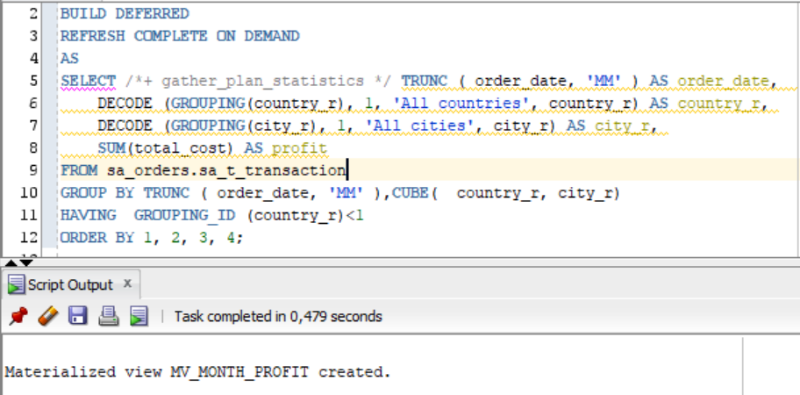

Аfter that let's select data from our view. Аs we can see the view remains empty:

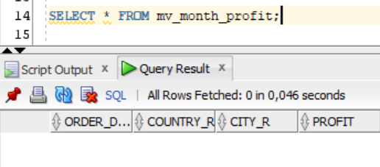

Now let's update our view using the function DBMS_MVIEW.REFRESH:

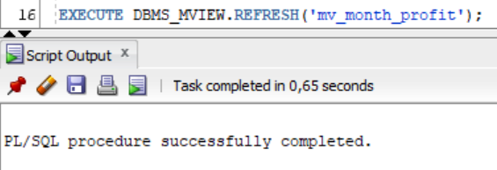

If we now execute select with our view, we will see that it is full:

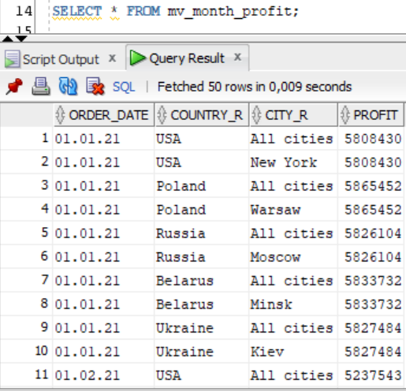

**Task 2 - Create Materialized Views - ON COMMIT**

Create materialized view log on our transactions table:

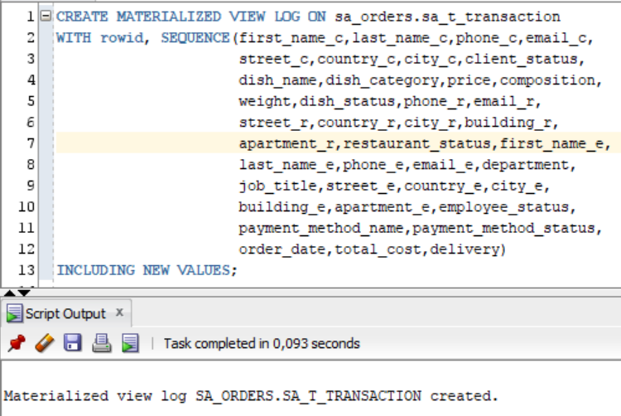

Create materialized view:

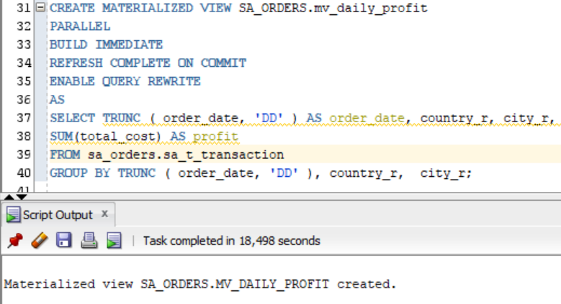

Аfter that let's select data from our view. Аs we can see the view remains is full:

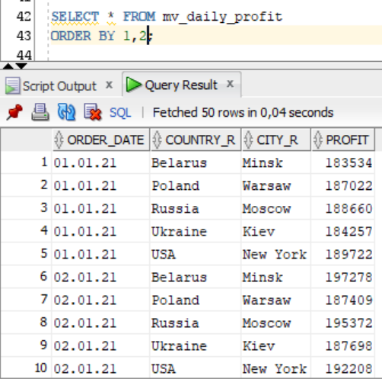

Now let's change the data in our resource table (increase total_cost by 2 times) and commit changes:

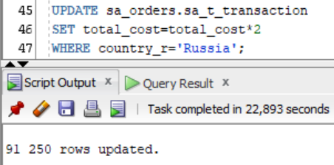

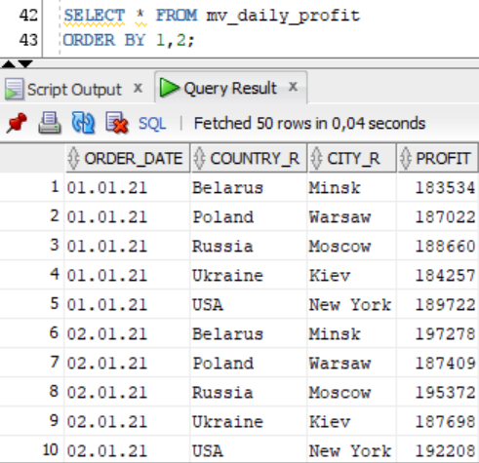

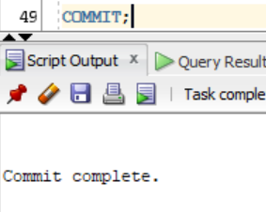

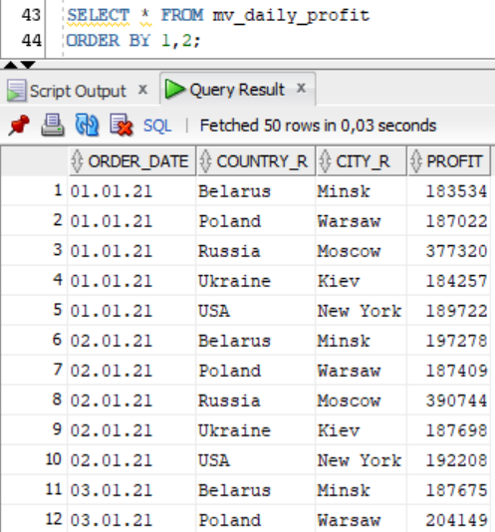

**Task 3 - Create Materialized Views - Refreshing at definitive Time moment**

Let's create a materialized view that will be updated every 5 minutes, based on a monthly report from 5 labs 2 tasks:

